**Assignment 5.1**

We have employee details and employee expenses files. Use local mode while running Pig and

write Pig Latin script to get below results:

<https://github.com/prateekATacadgild/DatasetsForCognizant/blob/master/employee_details.txt>

<https://github.com/prateekATacadgild/DatasetsForCognizant/blob/master/employee_expenses.txt>

Two datasets required for this Assignment are below:

**Employee_expenses.txt**

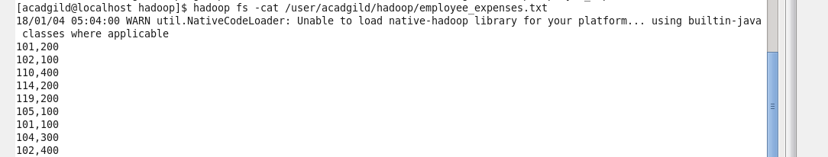

**Employee_details.txt**

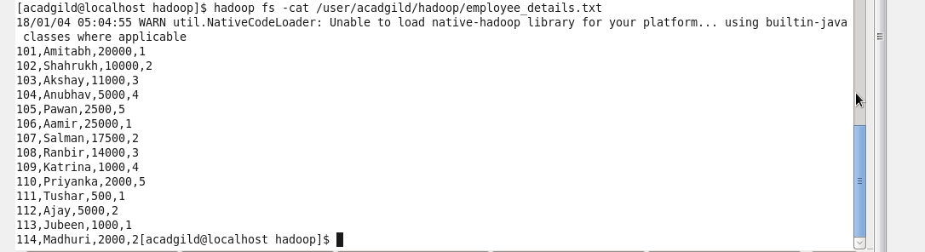

Loading both data sets in Pig environment

**Employee_expenses.txt**







**Employee_details.txt**







**Problem Statement 1:**

Find Top 5 employees (employee id and employee name) with highest rating (in case two employees have same rating, employee with name coming first in dictionary should get preference)









**Top 5 employees with highest rating:**



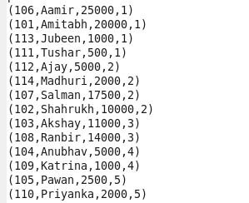

**Problem Statement 2:**

Find Top 3 employees (employee id and employee name) with highest salary, whose employee id is an odd number (in case two employees have same salary, employee with name coming first in dictionary should get preference)



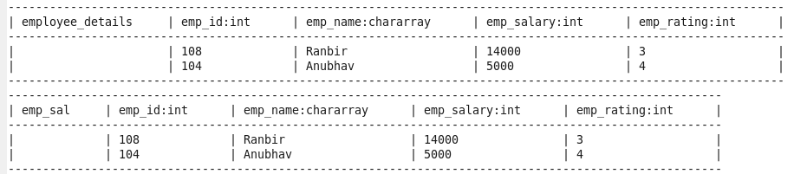





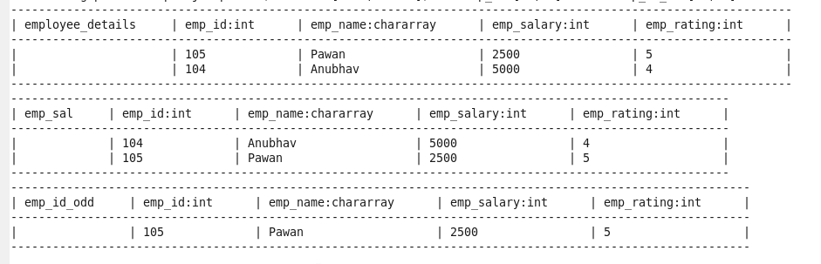





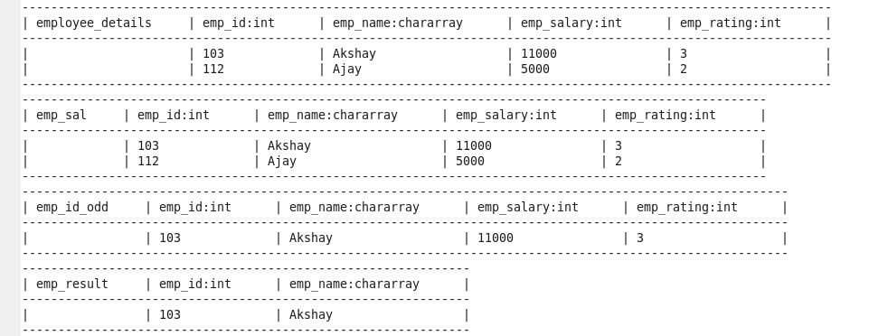





**Top 3 employees with highest salary:**



**Problem Statement 3:**

Find Employee (employee id and employee name) with maximum expense (in case two employees have same expense, employee with name coming first in dictionary should get preference)









**Employee with maximum expense:**



**Problem Statement 4:**

Find List of employees (employee id and employee name) having entries in employee expenses file.







**List of employees having entries in employee expenses file:**



**Problem Statement 5:**

Find List of employees (employee id and employee name) having no entry in employee expenses file.









**List of employees having no entry in employee expenses file:**

